About Company Introduction
Weihai Red Sun Printing Co., Ltd was founded in 1997, mainly engaged in the paper products --- printings and paper bags etc.
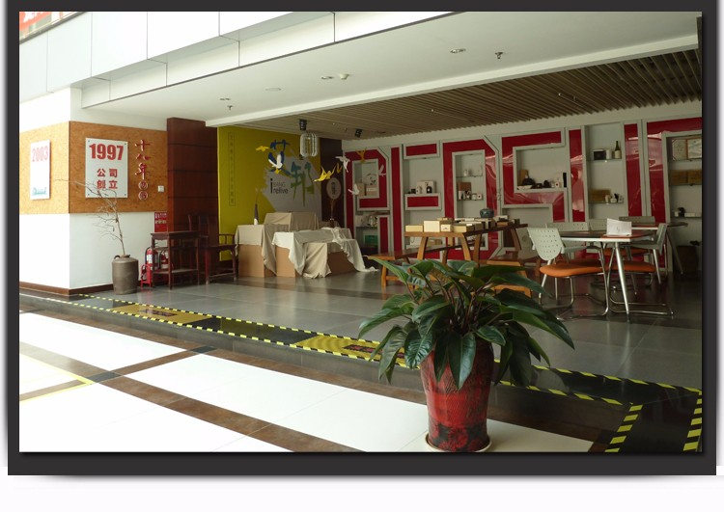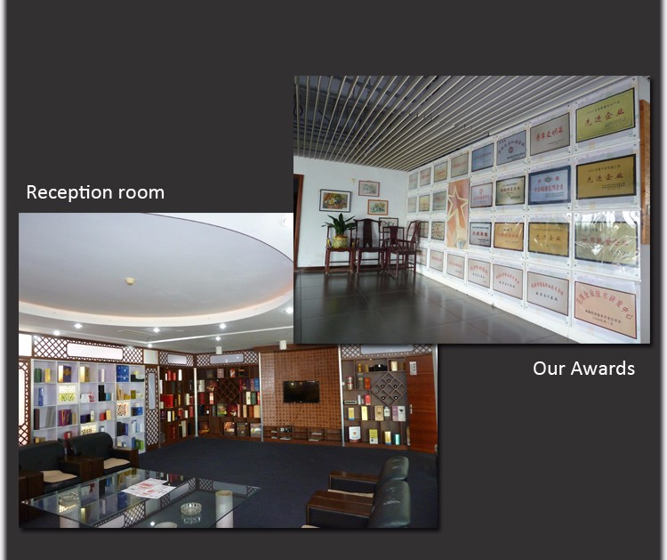

Company covers an area of 35,000 square meters, the existing assets is 85 million yuan, more than 256 employees are working in each different production lines.
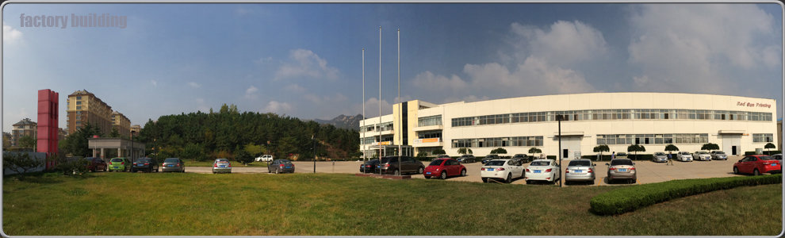
The company owns top equipments, leading technology and advanced technics, which has always been committed to serving the high-end customers and is one of the best commercial printing and packaging industries in China.
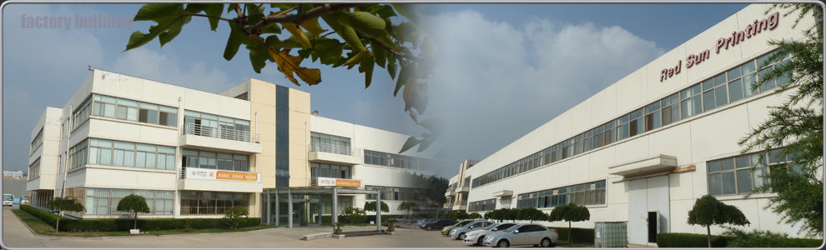
(1)The advanced CTP (computer to print) digital workflow to ensure the high resolution ratio for your artworks
(2)Two sets of world's highest quality printer Heidelberg CD102 / SM74 and one set of 5 colors printer Mitsubishi D3000C to ensure the color quality of the printings.
(3)The automatic film laminating machine / automatic die cutting machine / hot stamping machines / automatic folding and pasting machine are working coordinately to make sure the accurate date of delivery.
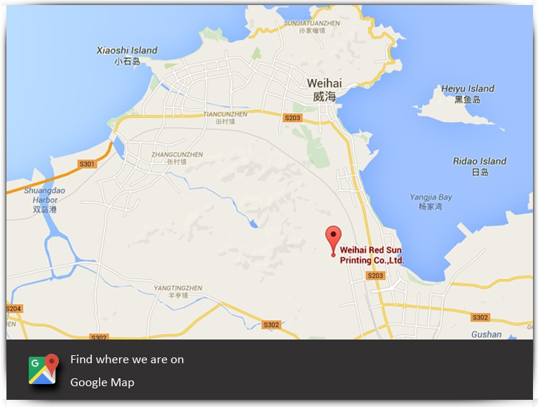

About Me

In 2014 into the red sun after printing, the position of a foreign trade supervisor, before working in Korean forwarder company for six years, mainly responsible for the return shipping to Korea Japan the United States and air transport business operations.
Our product with good quality and competitive price,which have been exported to many countries in the world.Looking forward to you contact us for future business relationships and mutual success!I hope I can be more professional and more sincere service for you.

Contact Information

Tel: +86 631 5900258
Fax:+86 631 5321788
H.P:+86 18769126186/13173312455
Skype:selina.redsun
E-mail:selin@redsunprint.com
Website:www.redsunprint.com
www.redsunprint.en.alibaba.com

